League of Legends Game Time

Jason Tang/Tang Song

December 13, 2015

*Abstract*

*This article investigates the factors that could affect the game time in a League of Legends ranked 5 vs. 5 match. We focused the analysis on the Kill Death Assist ratio, or “KDA”, which is a good measure of players’ performances in game. We intend to find out more about the relationship between “KDA” and the game time, and to understand if we can predict a game’s length by the player’s “KDA”.*

1. **Introduction**

League of Legends is currently one of the most popular E-Sport games in the world with an astonishing 27 million daily players. League of Legends is a multiplayer online battle arena (MOBA) video game developed and managed by Riot Games owned by the Chinese Internet Company Tencent Inc. In the typical game mode of League of Legends, players take on the role of an unseen “summoner” that controls a “champion” with unique abilities as a team of 5 “champions” that battles against another team of 5 “champions” with the mutual goal of destroying the opposing team’s “nexus”, a structure which lies at the heart of the base protected by defensive structures. Each League of Legends match is discrete, with all champions starting off fairly weak but increasing in strength by accumulating items and experience over the course of the game.

In this article, we explore the game mode “Ranked 5 versus 5” in which the game rewards players who win and punishes players who lose on an Elo rating system so that players can know how good they are with respect to everyone else. We chose the “Ranked 5v5” because players who play in this mode are likely to try their hardest to win to in order to improve their ranks. This is a more accurate reflection of the player’s skill level.

1. **Collecting Data Set**

In order to perform analysis, calculate descriptive statistics, and construct confidence interval on the game time, a considerable amount of sample data needs to be collected.

First, we will focus on and collect sample data games in different divisions in League of Legends. Based on players’ rank/ skill level, they can achieve different divisions in game. The divisions are, from lowest to the highest: Bronze, Silver, Gold, Platinum, Diamond, Master, and Challenger. The majority of ranked players (roughly 50%) are in Bronze and Silver, there is only about 2% of the player population who achieve Diamond or above ratings.

The sample size is set to be 500 in order to get a good distribution of match duration in each division. The way the data collection is done is through Riot’s API- application program interface. API allows others to gain data using different programs, so for this project we wrote a Java program that gathers information for us. We start the program with an empty stack of players’ IDs, and randomly find a bronze player’s ID to add into the stack. Then, while the stack is not empty, we pick the first player’s ID, and find his/her rank. If we do not have enough ratings for that rank, we continue to look into the second most recent game. We get the game time, his/her KDA and his/her statistics of playing that champion, etc. These extra information will be useful to perform regression in order to better understand how these statistics affect the game time.

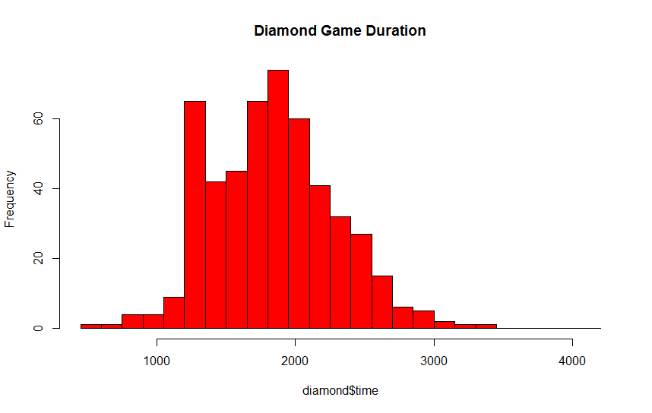

1. **Data Analysis**

After getting the sample data from Riot Games’ database, we computed the basic statistics regarding these sub-populations of different divisions. The mean and standard deviation (in seconds) of different divisions: (Silver – Diamond all have 501 sample size)

Bronze: (only 145 observations)

Mean: 2015.434 Standard Deviation:  466.0479

Silver:

Mean: 2003.012 Standard Deviation:  463.1363

Gold:

Mean: 1960.732 Standard Deviation:  493.964

Platinum:

Mean: 1902.152 Standard Deviation:   460.9656

Diamond:

Mean: 1834.708 Standard Deviation:   453.3165

Master: (only 286 observations)

Mean: 1750.997 Standard Deviation:   442.6166

Challenger: (only 58 observations)

Mean: 1781.931 Standard Deviation:   537.3203

The reason we do not have all 500 samples from all divisions is that, for Master and Challenger, there is simply not many players in these divisions (Master and Challenger only consists of the top 0.2% of the player population). Our program does not record repeated matches. For Bronze, we have only have 145 samples because not many Bronze players are dedicated enough to try to have better ratings. Therefore, there is a lack of data as Riot Games clears data out periodically.

We can observe that there is a decreasing trend in the mean of game time as we look at divisions from Bronze to Challenger in the order of increasing skill level. We hypothesize this decrease in mean is the reflection of the players’ different skill levels across divisions. As players become better at the game (i.e. get to higher divisions), they are more likely to capitalize on the opponents’ mistake and snowball the game further in their favor. Once a higher division team (teams in Diamond and above) gets a lead on the enemy team in terms of gold/experience advantage or champion strength, the players tend to use that advantage to win the game quickly, thus producing a shorter game time. Whereas, lower divisions teams and players (Bronze or Silver) do not necessarily know how to close out a game properly; both teams will make relatively more mistakes, failing to end the game early, thus producing a longer game time.

**Hypothesis Tests on the Mean:**

It is reasonable to suppose that game time is at least partially a reflection of the different in skill level across divisions. We conduct hypothesis tests on the mean of the game time to compare the mean across all different divisions to see if the means are the same or different.

The null hypothesis H0: µ1 = µ2

The alternative hypothesis H1: µ1 ≠ µ2

We have a relatively small sample size compared to the whole population, and since all the sample came from the same underlying population, we assumed that all the samples have the same population variance even though it is currently unknown. Therefore, we performed the hypothesis testing using the two-sided T-test under the equal variance assumption at an alpha level of 0.05 (α = 0.05);

Compare population mean of

Bronze vs. Challenger: P-value = 0.0038 < 0.05 Reject null hypothesis

Bronze vs. Master: P-value = 6*10^-8 < 0.05 Reject null hypothesis

Bronze vs. Diamond: P-value = 8.7*10^-5 < 0.05 Reject null hypothesis

Bronze vs. Platinum: P-value = 0.01 < 0.05 Reject null hypothesis

Bronze vs. Gold: P-value = 0.3366 > 0.05 Do not reject null hypothesis

Bronze vs. Silver: P-value = 0.96 > 0.05 Do not reject null hypothesis

Silver vs. Challenger: P-value = 0.00077 < 0.05 Reject null hypothesis

Silver vs. Master: P-value = 2.33*10^-13 < 0.05 Reject null hypothesis

Silver vs. Diamond: P-value = 8.5*10^-9 < 0.05 Reject null hypothesis

Silver vs. Platinum: P-value = 0.000581 < 0.05 Reject null hypothesis

Silver vs. Gold: P-value = 0.163 > 0.05 Do not reject null hypothesis

Gold vs. Challenger: P-value = 0.009982 < 0.05 Reject null hypothesis

Gold vs. Master: P-value = 4.18 * 10^-9 < 0.05 Reject null hypothesis

Gold vs. Diamond: P-value = 2.868*10^-5 < 0.05 Reject null hypothesis

Gold vs. Platinum: P-value = 0.05282 > 0.05 Do not reject null hypothesis

Platinum vs. Challenger: P-value = 0.06535 > 0.05 Sample too small to reject

Platinum vs. Master: P-value = 8.303*10^-6 < 0.05 Reject null hypothesis

Platinum vs. Diamond: P-value = 0.01987 < 0.05 Reject null hypothesis

Diamond vs. Challenger: P-value = 0.4112 > 0.05 Do not reject null hypothesis

Diamond vs. Master: P-value = 0.0122< 0.05 Reject null hypothesis

Master vs. Challenger: P-value = 0.6406 > 0.05 Do not reject null hypothesis

From the comparisons of the average game time across different divisions, we know that, to good amount of certainty, there is only a significant difference in the average game time between players of low and high divisions. For example, the hypothesis tests show that Bronze and Diamond average game times are different, but there is no strong evidence to support that Bronze games and Silver games have different game length on average. We also observe that the game time in lower division tend to be very similar, and the time difference gets larger as we go higher in divisions.

One of the reasons why the time difference gets bigger the higher the divisions is that better players know when and how to end the game. Another difference is that master and challenger players know how to build a team composition and they are very efficient with the use of their time so that they can get the most out of every minute. For the worse players, they play the game inefficiently. As such the players with the lower divisions have similar time but the higher division the better they are with the use of the game time. Also we need to note that there are only 200 challengers and 836 masters, compare to 34,438 diamonds and 723,000 silvers.

**Regression:**

After performing the hypothesis tests, we decided to look at factors that may influence the game time. The “Kill Death Assist” ratio, or “KDA”, of a player is calculated by his or her (Number of champion kills + assists) / (Number of deaths). The “KDA” is a one of the primary measures of a player’s performance in game. A player with very high “KDA” means the player successfully killed and/or assisted his team in taking out enemy champions without having to die many times in game. Thus, this player has made a great contribution to his team in winning the game. We collected the “KDA” data of players and their game time and performed the least square regression.

Note: players may have perfect “KDA”, meaning they have died exactly 0 times when the game ended. Strictly speaking, their “KDA” would be infinity. A value of infinity will greatly impact the meaningfulness of our analysis. In the regression model, we give perfect “KDA” a high value of 20.

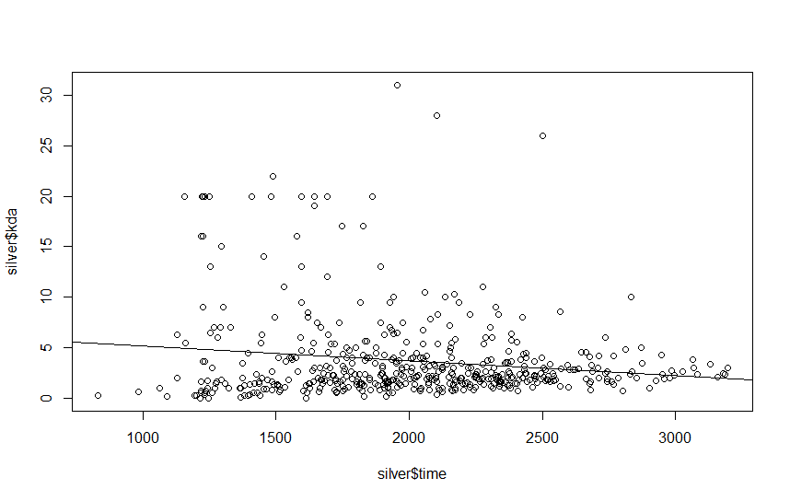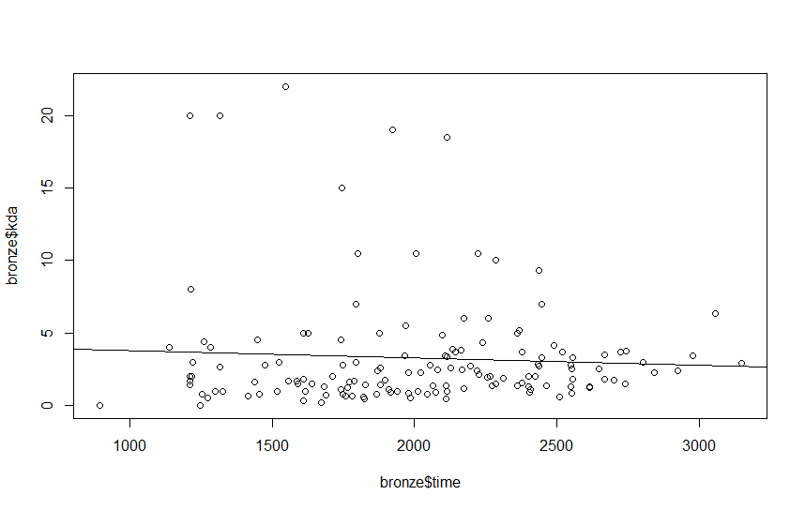**Bronze: (slope: -0.000495)** **Silver: (slope:  -0.00144)**

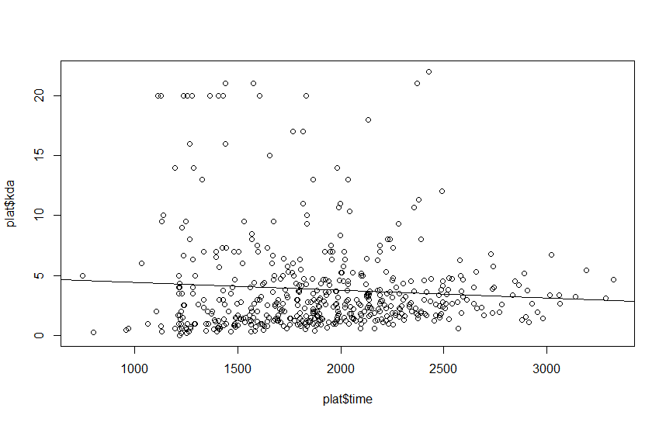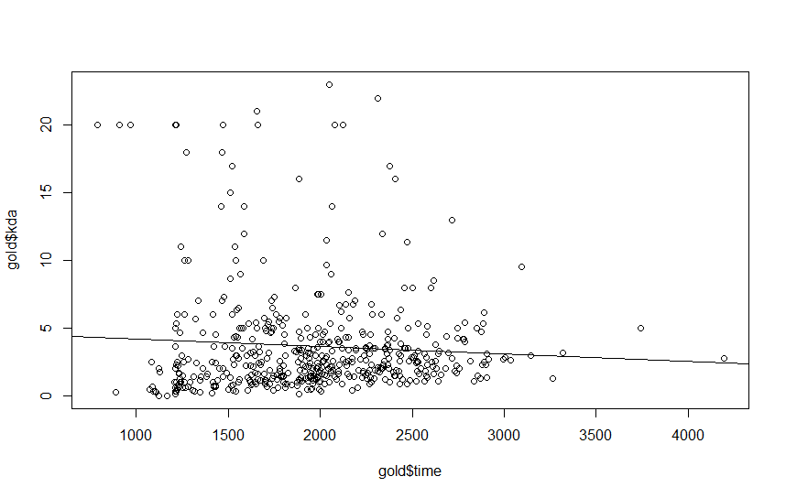**Gold: (slope:  -0.00055)**  **Platinum: (slope:  -0.00055)**

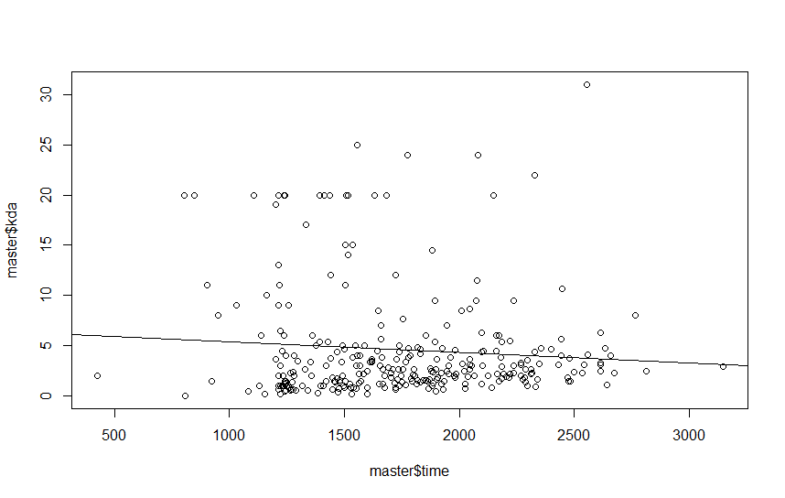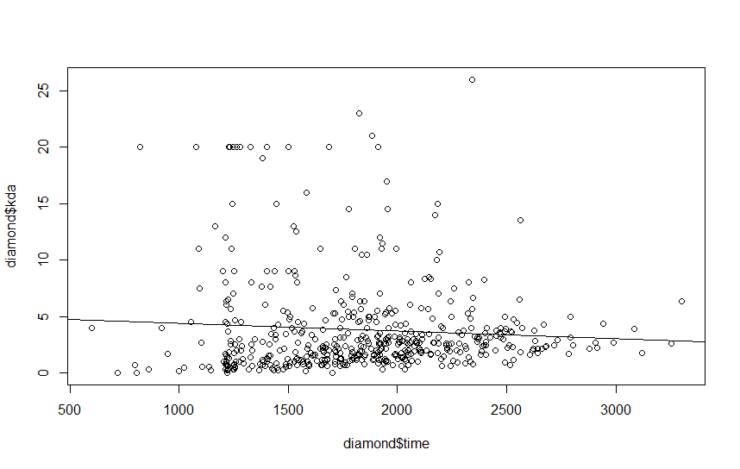**Diamond: (slope:  -0.000674) Master: (slope:  -0.00108)**

As we observe, the slope is very tiny. However, we cannot simply a hypothesis test to test if the slope is 0. That is because hypothesis test asks whether some relationship observed in a sample exists, but if the slope is 0, then there is no relationship. On the contrary, we can show that we cannot reject the possibility that the slope is 0. So, we did hypothesis test on silver and diamond sample, with and without the perfect KDA.

Silver: Without perfect KDA P value for slope is 0.164, and with perfect KDA it is 0.000475.  
Diamond: Without perfect KDA P value for slope is 0.365, and with perfect KDA it is 0.107.

As we can see, choosing KDA as 20 might not be the best idea as it changes the slope’s P value.

**Prediction Interval:**

In order to get a better understanding of how KDA affects the game time, we computed the 95% prediction interval. To save time and space, we took 1 subpopulation from the lower divisions: silver, and a 1 subpopulation from the higher divisions, diamond. With α = 0.05. We have:

|  |  |  |
| --- | --- | --- |
| **Silver**: Without Perfect KDA | | |
| KDA | 95% PI | Fit(center) |
| 0 | 1140.186 - 2945.76 | 2042.973 |
| 1 | 1132.511 - 2937.263 | 2034.887 |
| 2 | 1124.692 - 2928.91 | 2026.801 |
| 5 | 1100.372, 2904.712 | 2002.542 |
| With Perfect KDA | | |
| 0 | 1164.11-2966.746 | 2065.428 |
| 1 | 1147.663-2949.672 | 2048.68 |
| 2 | 1131.119-2932.696 | 2031.908 |
| 5 | 1080.904- 2882.35 | 2002.542 |

|  |  |  |
| --- | --- | --- |
| **Diamond**: Without Perfect KDA | | |
| KDA | 95% PI | Fit(center) |
| 0 | 942.6045-2714.629 | 1828.617, |
| 1 | 948.4479-2719.57 | 1834.009 |
| 2 | 954.1369-2724.666 | 1839.401 |
| 5 | 970.2769-2740.88 | 1855.578 |
| With Perfect KDA | | |
| 0 | 973.4305-2755.084 | 1864.257 |
| 1 | 966.0217-2747.016 | 1856.519 |
| 2 | 958.3928-2739.047 | 1848.78 |
| 5 | 935.3928-2715.736 | 1825.565 |

As for solely perfect KDA, the confidence interval for the mean is 1274.666-1592.606, with the center at 2003.201 for silver, and 1155.260-1509.407, with the center at 1323.333 for diamond.

As we observe, the perfect KDA’s confidence interval is completely different from the predicted intervals, whether they are with or without putting perfect KDA into account.

1. **Results and Interpretation**

From the hypothesis tests on the mean, we see the impact of varying skill level on the game length. Bronze/ Silver players tend to have a longer game than Diamond/Master players because the less experienced players are more prone to make mistakes that prevent them from effectively capitalize on their gold lead and enemy’s mistakes to quickly close out the game. Whereas, higher division players have a much better understanding in how to win the game quickly, so that, when given the opportunity, Diamond players will work together effectively as a team to out-smart the enemy and secure a quick victory.

We can say that the relationship between non-perfect KDA and game time is not as clear as perfect KDA and rank of the players. For perfect KDA, the game time reduces a lot regardless of what the rank of the players are. For different ranks, the higher the ranks the bigger the difference of the time and the shorter it takes. These hypothesized results makes logical sense in terms of the game play. As we have played this ourselves, if a player has achieved a high KDA, this player would be performing very well in that game, and is likely to lead his/her team to victory very soon. This effect is given stronger given a player has a perfect KDA. Given a player maintains a perfect KDA, his team is likely to have a lead that snowballs into a quick victory. Therefore, our data demonstrates the effect of perfect KDA having a larger impact on the reduction in game time.

1. **Difficulties and Limitations**

There are a few difficulties in this project, including the fact that there is no clear connection between KDA and the duration of game. We could not be certain if there is or not given what we used. On a similar note, we do not have enough data for some divisions, such as bronze, master and challenger. One of the reasons is that there are not that many players, but another way of data collection might be able to get more data entries than what we have. Finally, we valued all the perfect KDA the same, regardless of how much their actual contributions are. As such, the impact of perfect KDA in game time might not be well analyzed. A more throughout project could analyze solely the perfect KDA players to see their influence in the game time more directly than the holistic view that we implemented right now.